Multi Processor Systems
&
Processor Synchronization Issues

Concurrent Processing
Concurrent Processes are those, which are supposed to exist at the same time. They may be considered as clients to use shareable resources i.e., they may have access to same data or program sections. Such memory areas are called
Critical Sections because the operating system has to guarantee that only one process interacts with these at a time. Two major problems that the operating systems designers have to address for multi processor systems are Deadlock and Race Condition.

Deadlock or Stalemate Condition
A process in a multiprogramming environment is said to be in a Deadlock state if it waits for an event that will never occur e.g.

P1 requests Card Reader Serviced given
P1 releases Card Reader Serviced given
P2 requests Card Reader Serviced given
P1 requests Printer Serviced given
P2 requests Printer Not Serviced
P1 requests Card Reader Not Serviced

Conclusion:
- P1 & P2 are waiting for each other to release its resource.
- P1 wants to get Card Reader, which is not yet released by P2.
- P2 wants to get Printer, which is not yet released by P1.
- A DeadLock has occurred.
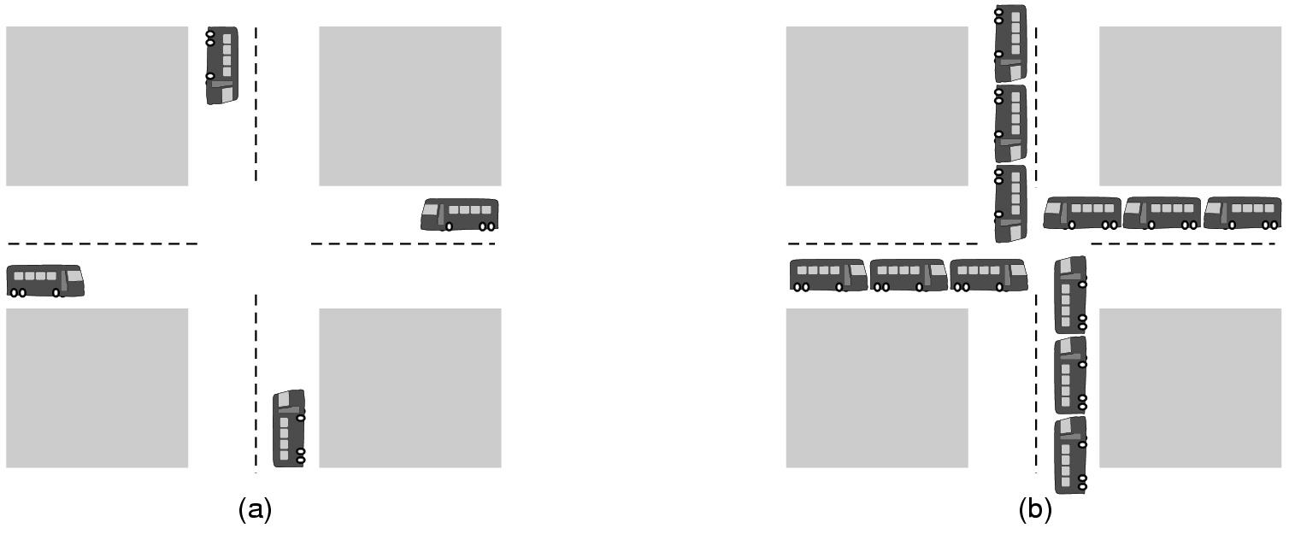

Deadlock in SPOOLing Systems
If several printable files are incomplete on the Spooler, none of these files will complete as spool area is exhausted and none of the files will qualify for printing.

Remedy for Deadlock in SPOOLer
Reserve large spool area stop receiving any new spool request after 75% full.

Four Conditions of Deadlock
- Mutual Exclusion: Processes claim exclusive control of resources they acquire. It means that Resources are not shareable.
- Hold & Wait: Processes hold resources already allocated while requesting/waiting for additional resources.
- No Preemption: The process may hold resources until it does not release it, i.e., preemption is not possible.
- Circular Wait: A circular chain is permitted, i.e., a process holds a resource requested by the other process.

Deadlock Prevention Policies
Although the prevention approach may lead to deadlock free implementation of an operating system but it may also lead towards Poorer Resource Utilization. Some approaches in this respect are:

Strategy 1 (Batch Environment)
- Each process must request all the required resources at once and may proceed until it succeeds.
Disadvantage: Unnecessary waiting for all resources although only a few may be used in the current run.

Strategy 2 – attacks the “No Preemption” condition
- If a process is denied allocation of additional resource, it has to release all the allocated resources and request for them again if required.
Disadvantage:

Strategy 3 – To avoid Circular Chain
- Imposition of a linear ordering of resources.
- All resources are arranged in ascending order (Normal order).
- Condition: Resource request(s) must be made in ascending order.

Other Approaches:
- The processes are allowed to approach a deadlock; but has methods to Avoid / Detect-Recover / Ignorance from such an event. It may be noted that the resource utilization improves in this case.

Deadlock Detection Mechanism
- All Resources get unique number.
- When Resource is allocated lock set.
- Maintain RA TBL (Resource Allocation Table)
- Maintain PW TBL (Process Wait Table)
- Entries made in both tables when resource status gets changed.
- When a locked resource found Deadly Embrace Routine is in run.
No
‘A’ Requests for Locked Resource
See who ‘B’ Locked it
Is ‘B’ Waiting
No Deadly Embrace

Check if ‘B’ waits for a resource blocked by ‘A’
Yes

Assume the following scenario: RA TBL

Resource Number | Assigned to Process #
R1 | P1
R2 | P3
R3 | P2
R4 | P2
R5 | P1

Sequence of Requests
- P1 requests R3
- P2 requests R2
- P3 requests R3

♣ P1 requests R3 → So J = 3 to search RA TBL
R3 is held by P2 → So K = 2 to search PW TBL
Process P2 is not waiting → So No Deadlock & P1 waits
Entry made in PW TBL

Resource Number | Assigned to Process # | Process No. | Resource being Required
R1 | P1 | P1 | R3 ♣
R2 | P3
R3 | P2
R4 | P2
R5 | P1

♣ P2 requests R2 → So J = 2 to search RA TBL
R2 is locked to P3 → So K = 3 to search PW TBL
Process P3 is not waiting → So No Deadlock & P2 waits
Entry made in PW TBL

Resource Number | Assigned to Process # | Process No. | Resource being Required
R1 | P1 | P1 | R3 ♣
R2 | P3 | P2 | R2
R3 | P2
R4 | P2
R5 | P1

♣ Now P3 requests R3
From RA TBL R3 is held by P2
From PW TBL P2 is requesting R2
From RA TBL R2 is held by P3

Resource Number | Assigned to Process # | Process No. | Resource being Required
R1 | P1 | P1 | R3 ♣
R2 | P3 | P2 | R2
R3 | P2
R4 | P2
R5 | P1

Conclusion:
Hence, P3 is requesting R3 held by P2, which is waiting for P3 to relinquish R2. Thus, a Deadlock has occurred between P2 and P3.

RA TBL PW TBL
Resource Number | Assigned to Process # | Process No. | Resource being Required
R1 | P1 | P1 | R3 ♣
R2 | P3 | P2 | R2
R3 | P2
R4 | P2
R5 | P1

Deadlock Avoidance

The Banker’s Algorithm for a Single Type Resource
A scheduling algorithm that can avoid deadlocks is due to Dijkstra (1965) and is known as the Banker’s Algorithm. It is modeled on the way a small-town banker might deal with a group of customers to whom he has granted lines of credit.

In Fig. (a), we see four customers, each of whom has been granted a certain number of credit units (e.g., 1 unit is IK dollars). The banker knows that not all customers will need their maximum credit immediately, so he has only reserved 10 units rather than 22 to service them.

In this analogy the customers are processes, units are resources (e.g. tape drives), and the banker is the operating system.

Name Used Max Name Used Max
Andy | 0 | 6
Barbara | 0 | 5
Marvin | 0 | 4
Suzanne | 0 | 7
Available : 10
(a) Available : 2
Andy | 1 | 6
Barbara | 2 | 5
Marvin | 2 | 4
Suzanne | 4 | 7
(b)
Andy | 1 | 6
Barbara | 1 | 5
Marvin | 2 | 4
Suzanne | 4 | 7
Available : 1
(c)

Fig. Three resource allocation states: (a) Safe. (b) Safe. (c) Unsafe

The customers make loan requests from the bank from time to time. At a certain moment, the situation is as shown in Fig (b). A list of customers showing the money already loaned (i.e., tape drives already assigned) and the maximum credit available (i.e., maximum number of tape drives needed at once later) is called the state of the system with respect to resource allocation.

A state is said to be Safe State if there exists a sequence of other states that leads to all the customers getting loans up to their credit limits (all the processes getting all their resources and terminating). The state of Fig. (b) is safe because with two units left, the banker can delay any requests expect Marvin’s finishes and releases all two of his resources. Now with four units in hand, the banker can let either Suzanne or Barbara have the necessary units, and so on.

Name Used Max Name Used Max
Andy | 0 | 6
Barbara | 0 | 5
Marvin | 0 | 4
Suzanne | 0 | 7
Available : 10
(a) Available : 2
Andy | 1 | 6
Barbara | 2 | 5
Marvin | 2 | 4
Suzanne | 4 | 7
(b)
Andy | 1 | 6
Barbara | 1 | 5
Marvin | 2 | 4
Suzanne | 4 | 7
Available : 1
(c)
Fig. Three resource allocation states: (a) Safe. (b) Safe. (c) Unsafe

Consider what would happen if a request from Barbara for one more unit were granted in Fig. (b). We would have situation Fig. (c), which is Unsafe. If all the customers suddenly asked for their maximum loans, the banker could not satisfy any of them, and we might have a deadlock. It’s not necessary that an unsafe state would always lead to a deadlock, since a customer might not need the entire credit line available, but the banker cannot count on his behavior. So it may or may not lead to a deadlock. Both things are possible.

The banker’s algorithm is thus to consider each request as it occurs, and see if granting it leads to a safe state or not. If it does, the request is granted, otherwise, it is postponed until later. To see if a state is safe, the banker checks to see if he has enough resources to satisfy the customer closest to his or her maximum. If so, those loans are assumed to be repaid, and the customer now closest to his or her limit is checked, and so on. If all loans can eventually be repaid, the state is safe and the initial request can be granted.

